Neural Net Exercises: Matlab Pattern Recognition Learner or Fitting Learner

Datasets are either in data folder or in Matlab’s demo dataset directory.

1. Use Matlab’s **Neural Fitting Learner** to build a numerical prediction model using the sample dataset Building Energy. You can load it directly from the Neural Fitting App without using the command line. This dataset has 14 features (see below) and 3 targets to calculate the energy usage of a building. Please
   1. Build a Neural net model using the default 10 neurons in the hidden layer. Explore the various outputs/plots. Report the regression plots. What’s the test set’s R value? This App uses the validation set’s result to determine when to stop the training. Can you tell at which epoch did it stop?
   2. Build the model again with only 3 neurons in the hidden layer and compare the result with your first model.

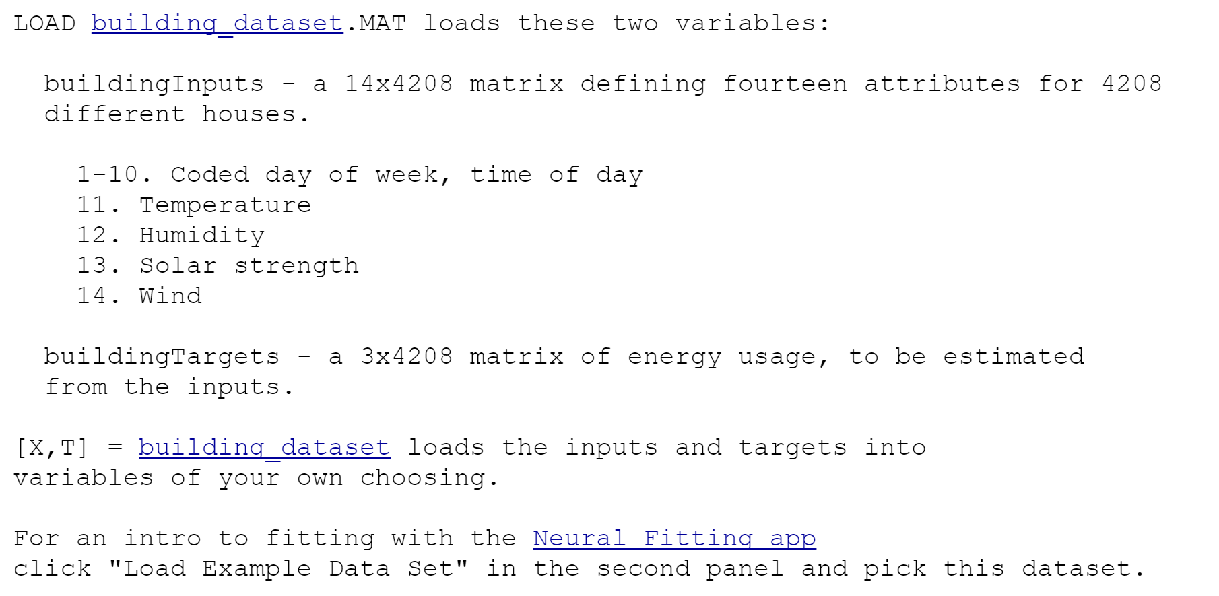

For examples of using another sample dataset see the following link:

<https://www.mathworks.com/help/deeplearning/gs/fit-data-with-a-neural-network.html>

1. Handwritten digits recognition
   1. The dataset is same as the one in the Classification exercise.
   2. MNIST2 in the Datasets directory is a version of the MNIST handwritten digits data. Each image is represented by 20x20 greyscale array that has been transformed to a 400 element vector. The last column represents the labeled classification of 0-9 for each image.
   3. Note the Neural Net **Pattern Recognition Learner** does not do one-hot coding of the Y variable for you. A sample code to do it is in the Week 5+6 Matlab package.
   4. Use the data to train a classification Neural Net model to recognize the handwritten digits.
   5. Compare the Neural Net model’s performance with the classification models you built before.
2. Handwritten digits recognition using Convolutional Neural Net.
   1. Open the example of Matlab Convolutional NN for digit recognition



* 1. Run the example to create a CNN called Net. Import Net into the Deep Learning Designer App.
  2. Use ‘Analyze’ (button on ribbon) to see what’s inside the CNN. How many layers do you have now? What’s the number of weights in the fully connected layer?
  3. Add additional layers to the CNN as depicted below and Analyze it again. How many layers do you have now? What’s the number of weights in the fully connected layer?

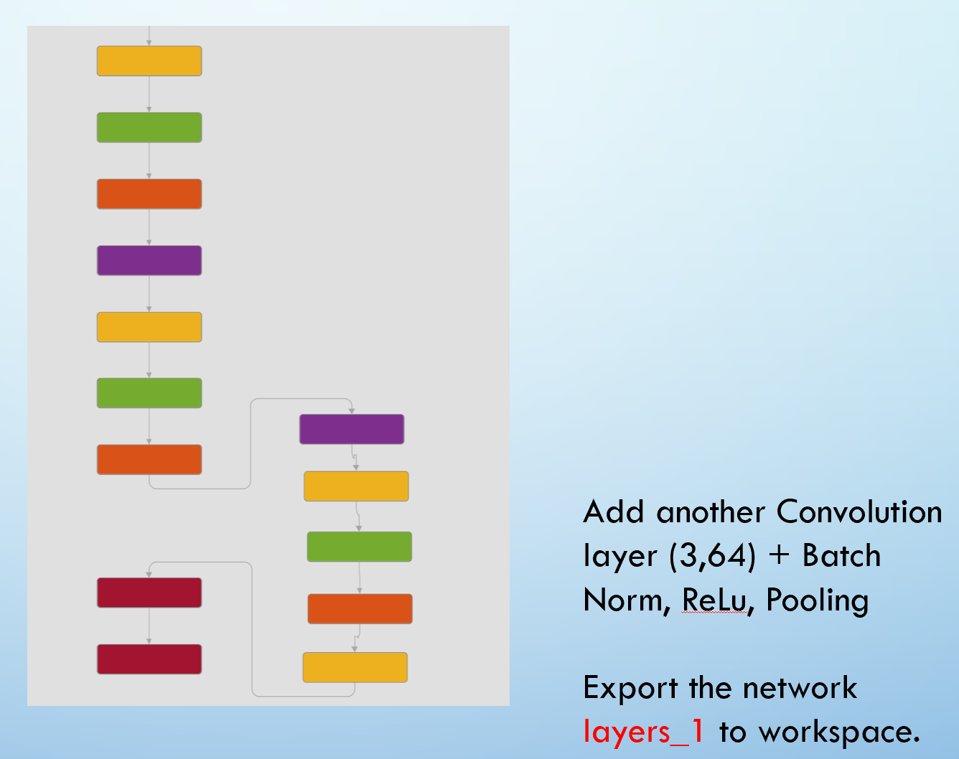

* 1. Export the network to worksplace and train this new CNN.
  2. Compare the performance of this CNN with the original CNN and your previous models.

#4 #5 #6 are Optional

1. Breast cancer data: Use the dataset “Breast Cancer Wisconsin.xls” to build a Neural Net model to diagnose breast cancer. This dataset is the same one used in the previous assignment.
   1. Build a classification model using Neural Net **Pattern Recognition Learner** and compare its performance (validation error, confusion matrix etc.) with the model you built with other methods.

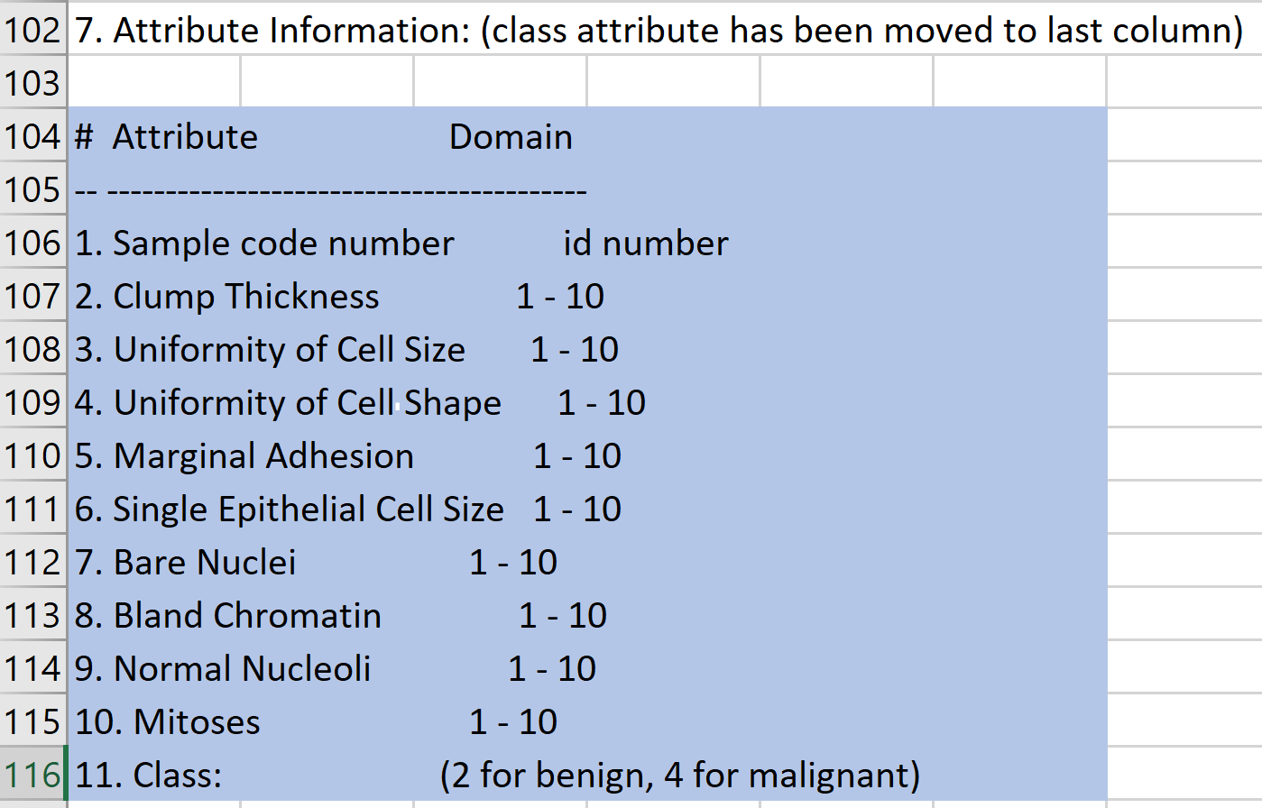

1. Credit Rating Data
   1. The dataset is same as the one in the Classification exercise. Note the Neural Net pattern recognition learner does not do one-hot-coding for you. You need to convert the credit ratings to one-hot encoding first.
   2. Load the Credit Rating Historical data from Matlab’s demo datasets using the instruction below.
   3. Note that 1st column is ID, the 7th column is industry group. The last column is one of the 7 ratings (AAA🡪CCC)
   4. Build a classification Neural Net model without the ID and industry group to generate credit ratings of companies.
   5. Compare the Neural Net model’s performance with the classification models you built before.
2. Use Matlab’s Hospital dataset. Explore the data and build a Neural Net model using Neural Net Fit Learner to predict patients’ blood pressure. Compare with the regression model you built before.

